PHYS 466, Term Project Report Team 1

Simulating the spread of COVID-19 using a Markov random walk model

Members
Junyan He, Samuel Aguiar, Albert Wiryawan,

Abstract
Numerous research efforts have been devoted to study the transmission dynamics of Covid-19 ever since the beginning of the Pandemic. In this report, we constructed a Markov random walk model to simulate the spread of COVID-19 in a hypothetical square domain. This model divides all particles in the domain into five categories, susceptible, infected, exposed, quarantined and removed, with user-defined transition probabilities to transition from state to state. To improve fidelity of the simulated dynamics, each agent in the system is free to move randomly in the two-dimensional domain. We proposed a distance-based probability distribution function to estimate the probability of an agent transitioning from susceptible to exposed, with transition to other states being determined by a set of probabilities. To include the effect of government virus protection guidelines, we include the effect of social distancing when moving the position of the agent via a rejection technique. We also allow for the occurrence of large gatherings by introducing a special move function for certain agents. The main model parameters were calibrated against published transmission record. The developed model is used to study the effects of: 1. Mask wearing percentage; 2. Social distancing; and 3. Large gatherings on the overall transmission dynamics. Through the simulations, it was found that increasing mask adherence and implementing social distancing rules to be an effective way to reduce both infection fatality ratios and population normalized case rates. Holding large social gatherings, however, leads to an abrupt increase in case count and a doubling in death rate.

- Introduction
The 2019 Novel Coronavirus and its associated acute respiratory disease, Covid-19, has been described by the U.S. CDC as a “serious global health threat” [1] with over 15 million total cases and 285 thousand total deaths as of December 9th, 2020 reported since January 21st, 2020 in the U.S. alone [2]. The infection fatality ratio (IFR), which is the ratio of total deaths divided by total cases, has been estimated at approximately 1.15% for developed nations [3, p. 34]. In context, the IFR of Covid-19 is roughly 10 times that of seasonal influenza [4]. Covid-19 was also identified as the leading weekly cause of mortality in the U.S. on December 4th, 2020 by the IMHE, surpassing ischemic heart disease; Tracheal, bronchus, and lung cancers; and chronic obstructive pulmonary disease [5]. Though all age groups appear to be susceptible to infection [6], young adults and children with the disease typically present asymptomatically or are considered “mild” cases where symptoms are characterized by fever, fatigue, and dry cough [7]. Adults 60 and older typically have much more severe symptoms sometimes requiring ICU treatment to combat dyspnea [8] and respiratory failure [7]. Waves of Covid-19 infection have been seen across the U.S. since the start of 2020. Most often, cases per 100,000 population is used to track the severity of an epidemic within a locality. As of Dec 5th, 2020, the population normalized case (PNC) rate in Illinois was 5,994 cases per 100,000 residents [9].
Transmission of the virus occurs in all infections regardless of if an individual is symptomatic. One known route of person-to-person transmission is through inhalation of droplets generated by sneezing and coughing from an infected individual [10]. These droplets are thought to travel between 1-2 meters [6], but a review of horizontal droplet spread showed much further travel distances of up to 8 meters were found in the literature [11]. It is also thought that infection rates could be between 2-10 times higher as distance between individuals is reduced from 2 meters to 1 meter [12]. Reduction in transmission has been seen when implementing standard droplet PPE. In particular mask wearing was shown to be effective in reducing transmission in clinical settings between 10-14% [13]. Further attempts at reducing widespread interaction have come in the form of “pods” or “cohorts”. These are small groups that agree to limit interactions outside of the group to limit the potential for virus transmission. Though this has been advertised by the CDC as a potential way to reintroduce public schooling [14], little data is available either in support of or against this practice. Successful infection transmission models thus rely on inclusion of a distance dependent transmission rate that includes mask wearing at various adherence levels. The inclusion of “podding” or social gatherings in transmission models also requires further investigation.
Once exposed, incubation periods before the onset of symptoms are between 1-14 days [7]. In this time viral load increases until it reaches a maximum during the first week after symptom onset [15]. Though it is not known how fast the testing system used at the University of Illinois at Urbana-Champaign [16] can detect Covid-19, it is assumed for modelling purposes that during the incubation period, exposed individuals do not test positive, but after the incubation period do test positive. We also assume a 100% test accuracy according to the duplicate sampling protocol currently in place [16]. Current CDC guidelines for those who have tested positive for Covid-19 include a 14 day quarantine or if possible isolation period [17]. Once this period passes a once infected individual will likely not transmit the disease. However, cases have been reported of second bouts of Covid-19 with the cause attributed to reinfection or reactivation of the virus [18]. In addition, recent surveys have indicated 96% of people who tested positive for Covid-19 would go into quarantine [19]. For this reason, models should include a mechanism to allow for reinfection of individuals as well as account for a certain degree of non-compliance in quarantining.
Previous works used to simulate spread of viruses are based on the Susceptible – Infected – Removed (SIR) model [20]. This model is comprised of a system of coupled ordinary differential equations that allow “agents” to occupy different states and transfer between them. Assuming periodic boundary conditions the sum of all the agents is constant. Susceptible agents are a general initial state that can become infected by other agents. The infected state describes actively infectious agents. Finally, removed is for any agents that die or become immune effectively removing them from the simulation. This model can be extended further into five categories, susceptible, exposed, infected, quarantined and removed, with user-defined transition probabilities to transition from state to state. Here, exposed agents have been in contact with an infected agent but are currently in an incubation period where they cannot infect others and do not yet test positive in Covid-19 screening tests. The quarantined state reflects infected agents who had tested positive in a Covid-19 screening tests and were removed for the simulation until they recovered. A flow diagram showing the possible transitions is shown in figure 1. These model extensions are useful to more accurately describe the dynamics of Covid-19 following current quarantining guidelines, testing protocols, and knowledge of transmission with a delayed response to virus exposure. The objective of this work is to give qualitative answers to the following: Does wearing masks change the rate of transmission? Would implementing an extreme social distancing approach reduce transmission further compared to current guidelines and no social distancing? Does limiting or prohibiting large gatherings reduce the risk of COVID-19 transmission? The organization of this report is as follows: first, the Markov random walk algorithm is described in Section 2, with an emphasis on how the social distancing rules and gathering of agents are enforced in the model. Section 3 presents the calibration process and the results for each proposed study. The results are also discussed in Section 3 and conclusion is given in Section 4.
Figure 1. Potential agent states Transitions
- Algorithm development
In this work, a Markov random walk framework was employed in Python to simulate the transmission dynamics of Covid-19. Here, we place our focus on the transient transmission dynamics instead of the equilibrium condition. A Markovian process is characterized by a current state and transition rules for the current state to evolve into the future state, and these transition rules are used repeatedly to update the state for a user-specified number of steps. Therefore, in what follows, we describe in detail how we construct the initial state, as well how to construct realistic transition rules/probabilities to evolve the states.

2.1 Construction of initial state
The simulation domain is set to be a square with a user-provided dimension. This domain is first discretized, for the sake of initialization, into a N_{i} by N_{i} uniform grid, where:
$N_{i}=ceil(\sqrt{N})+2$,
and N is the total number of agents in the system. Each agent in the system is then randomly assigned a unique grid location, with some grid locations left unoccupied. This brings some degree of randomness into the initial state, but it is still obvious that most agents sit on a regular grid. To further introduce randomness into the initial state, we perform a user-specified number of passes over the agents to move their positions without considering any transmissions. In a Cartesian coordinate system, an agent move can be uniquely characterized by a direction angle $θ$ (with respect to the positive X direction) and a move distance $d$. It is important to highlight that from this point onward, the agents are not limited to sit on grid points: they are free to move anywhere in space (except to avoid overlap and enforce social distancing, as will be discussed later). Therefore, both $θ$ and $d$ are continuous random variables. In this work, we sample the angle $θ$ from a uniform distribution in the range of $[-π,π]$ and the distance $d$ from a normal distribution with a user-specified mean moving distance and a standard deviation. The updated coordinates are periodically wrapped to its minimum image to enforce periodic boundary condition on all domain edges. After passing through all the agents to advance their positions, a random list of infected, mask-wearing agents is chosen. If the user allows for gathering to occur, a list of agents to hold the gatherings is chosen as well. This completes the construction of the initial state.

2.2 Avoiding overlaps and enforcing social distancing
Since the agents are free to move in the simulation domain, we need to avoid overlap of agents to avoid unrealistic transmission dynamics. In addition, to study the effect of social distancing, we need to ensure that the inter-agent distance is greater than the specified value. To this end, we introduce a distance-based rejection criterion.
Every time an agent’s position is changed, we check the distance to its nearest neighbor. The nearest distance is obtained via a KD tree, constructed using the KDTree function from the scikit-learn package in Python. When the social distance rule is not enforced, we require the minimum distance to neighbors to be greater than 1.5ft, the average shoulder width of an adult. This gives a physical size to the agents, resembling a hard-sphere model, where each agent is a rigid sphere with a given radius, within which the interparticle force is infinite. When social distancing rule is enforced, the minimum inter-agent distance is to be greater than 6 ft, as set by current guidelines [17, p. 19]. A proposed move is rejected if this leads to a smaller than allowed minimum distance, and the original agent position is restored. If the minimum distance constraint is satisfied, we accept the move with the following probability:
$$P_{acc}=exp(-d_{m}/2)$$
where $d_{m}$ is the minimum distance to the neighbour in ft, and the normalization factor is set to 2 ft, the size of an intimate zone, according to social studies [21]. The acceptance ratio in each pass is recorded to track the efficiency of this rejection technique.

2.3 Formation of gatherings
When gatherings are allowed, we expect agents to come close to a nearby gathering host and remain in its vicinity for a certain period of time. We introduce this effect into the simulation by creating a special move in this case. First, when passing through an agent to make a move, the minimum distance to any gathering hosts is determined via a KD tree. If this distance is smaller than a radius of influence, then with some certain probability (as determined from a random draw), the agent will join this gathering. To emulate the effect of agents remaining close to the center of the gathering, we do not compute an agent displacement and add to its last position, as we do in a regular move. Instead, we directly assign a new agent location based on the following formula:
$$X_{new}=X_{center}+Δd$$
where $X_{center}$ is the location of the gathering host, and $Δd$ is a displacement relative to the host, computed by randomly drawing a direction and a distance from corresponding distributions. The maximum magnitude of the relative displacement is the influence radius of the gathering, as set by the user. At each pass, each agent has a certain probability to leave the gathering, and the usual method, as described in Section 2.1, is used to update its location. Overlap check is enforced to ensure realistic dynamics. To allow a higher acceptance ratio when having gatherings, we disable social distancing when gathering is in place.

2.4 Transition probabilities
An agent can take five possible states: susceptible, exposed, infected, quarantined and removed. The agent can change its state with some certain probabilities. These probabilities control the dynamic behavior of the transmission process, so it is important that their construction is physically based and calibrated to experiment observations.
The first transition is from susceptible to exposed. We postulated that this is probabilistic and can be related to the nearest distance to an already exposed/infected agent. To calculate this probability, this minimal distance to an exposed/infected agent is first determined from a KD tree. Then, we proposed the following empirical relation:
$$P_{exposed}=C_{mask}P_{0}[1-tanh(\frac{d_{c}}{d_{ref}})]$$
where $C_{mask}$ denotes the mask coefficient ($C_{mask}$<1), which characterizes how much safer you will be with a mask, compared to not having one, when maintaining a fixed distance to an exposed agent. $P_{0}$ is the intrinsic probability of exposure to the virus. $d_{c}$is the minimal distance to an exposed agent, and $d_{ref}$is a reference distance to scale the distance dependence of transmission probability. $C_{mask}$, $P_{0}$, and $d_{ref}$ are user-defined parameters, whose values are to be calibrated to fit known transmission data. This equation gives a smooth decrease of the exposed probability from $C_{mask}P_{0}$ down to 0 as the minimal distance increases to infinity, whose trend is realistic: one expects a lower chance of being infected as the separation distance increases. To determine the state of the agent, a uniform random number in the range of $[0,1]$ is drawn, if the number is smaller than $P_{exposed}$, the state of the agent is updated to exposed.
The transition from exposed to infected is considered deterministic, for simplicity of the current study. The state of the agent will transition from exposed to infected, once a user-defined latent period (14 time steps) has expired. Once the agent changes to being infected, it is tested for Covid-19 with a certain probability. Once tested, the agent has a certain probability to become quarantined. Both processes are lumped into a single random number draw. Once quarantined, the position of the agent is held fixed in the domain, and it loses its capability to transmit the disease. All exposed/infected/quarantined agents have a probability of becoming removed (deceased) or recovered. Again, both state transitions are determined by a random number draw with user-provided probabilities to be calibrated. For simplicity, once the agent is recovered, it is considered susceptible again, without any immunity to the disease. Once an agent is removed, it is simply deleted from the system and is not considered in the transmission thereafter.
This completes the essential rules to traverse the state space. After each pass (time step), the complete state of the system is surveyed. The number of agents in each state are recorded and stored to obtain statistics. A function was implemented to plot the current position and states of the agents in the simulation domain. IFR and PNC are tracked throughout the simulation to serve as calibration metrics.

2.5 Transition probability calibration
Limited numerical data is known for the detailed dynamics of Covid-19 transmission. However, infection fatality ratio (IFR) and population normalized case (PNC) are two parameters well reported thus far in the literature that can be used to calibrate the model. Key parameters to be calibrated include $P_{0}$, $d_{ref}$ and probabilities of death and recovery from the virus. For all other model parameters, reasonable fixed default values were assigned. The tunable parameters were adjusted to match model outputs with a reported mean infection fatality ratio (IFR) of 1.15% [3, p. 34] and a population normalized case (PNC) rate of 5,994 cases per 100,000 population as reported for Illinois on Dec 5th, 2020 [9]. During the calibration, it was assumed 96% of the population normally wears masks. The authors chose this value under the assumption current mask wearing practices match the percentage of people who would quarantine if they tested positive for Covid-19 [19].
To calibrate the model, the transmission dynamics was simulated for 100 time-steps, which is sufficient to approach steady state. It is important to note that in this work, we focus on the dynamics, instead of the steady state properties, hence the small number of steps. This also implies the lack of ergodicity: we cannot simply use time average to replace ensemble average as we did in class assignments. To this end, we repeat the simulation by 1000 times to get statistics. After calibration, the mean IFR is 0.9%, while the mean PNC is 5.85%. The calibrated model parameters are presented in Table 1.
Table 1. Calibrated model parameters
 | $$P_{0}$$ | $$d_{ref}$$ | $$P_{Death}$$ | $$P_{Recovery}$$
Values | 70% | 3ft | 0.3% | 20%

- Results and discussion
A verification test was first conducted to confirm the correctness of the social-distancing implementation as well as the special move for holding a gathering. Then, the effects of three social behavior modification variables on the transmission were explored in this study: mask wearing percentage, social distancing, and holding gatherings. In each case, a qualitative assessment on whether enforcing the measure is beneficial is made based on quantitative changes in IFR, PNC, and the simulation dynamics.

3.1 Verification
The first key functionality to verify is the social distancing. To this end, we initialize a state of 150 agents following the procedure outlined in Section 2.1, devoting 20 time-steps without transmission to randomize the agent positions. When social distancing is not enforced, the acceptance ratio is 68.25%, with the minimum inter-agent distance being 1.76ft, slightly larger than that specified by the overlap constraint of 1.5ft. Whereas in the social distancing case, the minimum inter-agent distance is 6.15ft, and the acceptance ratio dropped down to 17%, due to the large inter-agent distance (6ft) it needs to maintain in a fairly crowded region. Figure 2 depicts the initial state for the two conditions, which clearly demonstrate that the constraint is working as expected.
The second key functionality is to include the effect of holding gatherings. We demonstrate the functionality with a state of 80 agents, giving it larger average inter-agent distance. Furthermore, social distancing was enforced during initialization stage. The system was subsequently evolved without social distancing for 10 steps. Figure 3 depicts the comparison. From this figure, it is obvious that a gathering has formed near the only host in the system after just 10 steps, significantly lowering the inter-agent distance within the gathering.
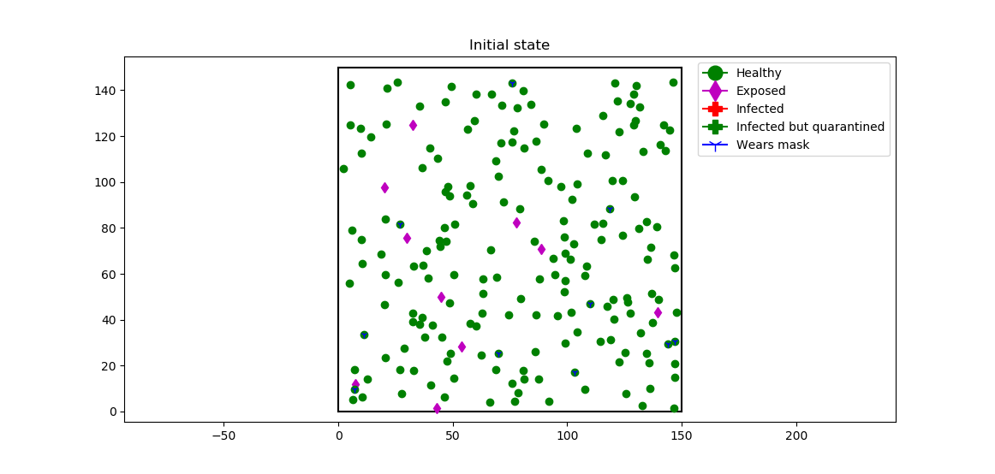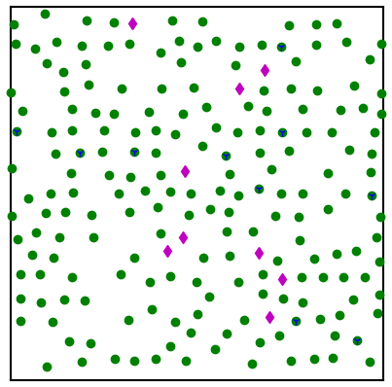
Figure 2. Comparison of two initial conditions. No social distancing (left) and social distancing (right). The inter-agent distances are clearly more uniform in the second case.
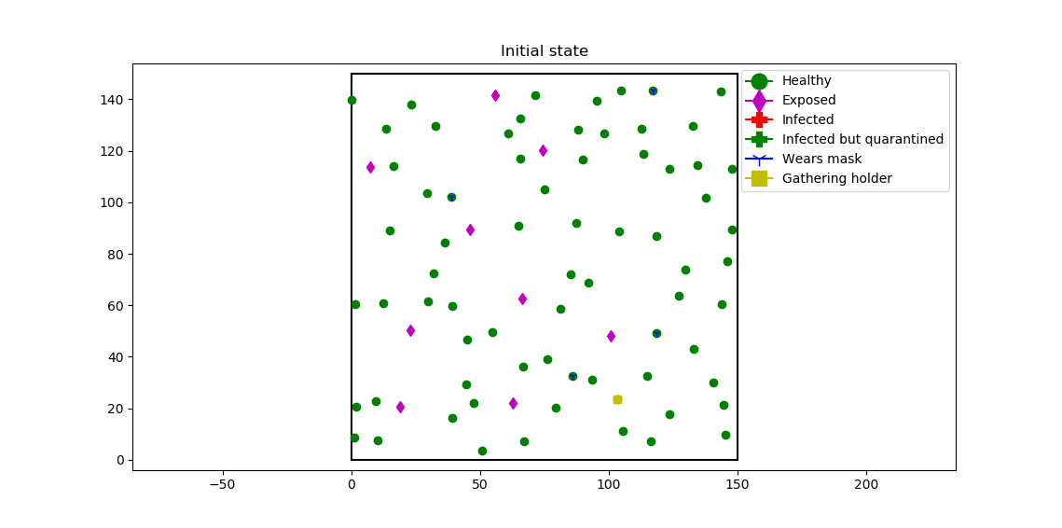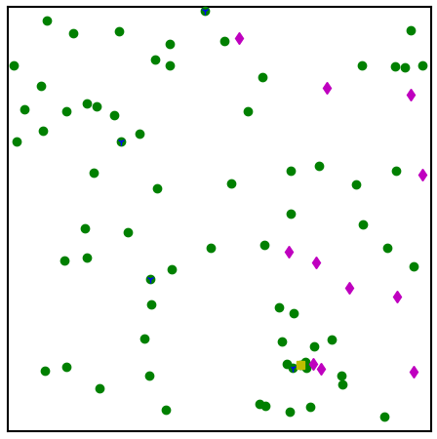
Figure 3. Demonstration of the special move for holding gatherings. The initial state (with social distancing enforced) is shown on the left, while the state after 10 time-steps (with no social distancing) is shown on the right. The position of the gathering is highlighted with a red circle.

3.2 Effect of mask wearing
First, the effect of mask wearing on IFR and PNC was investigated. Five levels of mask wearing percentage: 0%, 25%, 50%, 75%, and 100% were considered in this case. For each percentage, 1000 independent repetitions were conducted. Each repetition was evolved for 250 time-steps, a time long enough for the system to approach steady state. The mask coefficient $C_{mask}$ was set to 0.5 in all simulations. The plot of PNC against different mask wearing rates is shown in Figure 4, which shows that as the population of mask wearers increased, the PNC decreased.
Figure 4. Plot of PNC vs. different mask wearing percentages. As expected, PNC decreases with increased mask wearing percentage.
Figure 5. Plot of IFR vs. different mask wearing percentages. The simulation shows that IFR is increasing with increasing mask wearing percentage.
In contrast, IFR shows a slight increase as mask wearing percentage increases, as can be seen in Figure 5. This may seem odd at first, as this seems to indicate that mask wearing is ineffective and even leading to more deaths. Note that IFR is defined as the ratio between the number of deaths and the number of infected agents. Since PNC (number of infected agents divide by population size) is decreasing at a higher rate as mask wearing percentage increases, the total number of deaths actually decreases. The data shown in figures 4 and 5 show that mask wearing is an effective measure of reducing the number of cases and preventing deaths, which is in-line with what government guidelines are advocating.
When the ensemble-averaged transmission dynamics is inspected, the effect of mask wearing is more pronounced. The transition dynamics is shown in Figure 6. As shown in the figure, more agents remain susceptible (uninfected) as more mask are worn (Figure 6A). At the peak of the transmission, less agents are infected (Figure 6B) and quarantined (Figure 6C) as a result. However, although mask wearing is protecting more agents to stay healthy, it does seem to increase the population normalized death rate, although the highest death rate is much less than 1% in all simulations. Given that mask wearing is one of the main mitigators to Covid-19 transmission, one might suspect a larger increase in the number of exposed agents as fewer masks are worn. But at the low initial concentration of infected individuals (~5%) used here, the limited number of additional exposed agents is quickly diluted by a high testing and quarantine rate. Therefore, from the results of the simulation, we can conclude that wearing a mask is an effective way to slow down virus transmission and protect more people from falling ill.

3.3 Effect of social distancing
Next, the effect of implementing a social distancing scheme at a constant mask adherence rate (96%) throughout the population was investigated. In the simulation, the minimum distance to maintain is 6ft, as in current government guidelines. For each case, 3000 independent repetitions were conducted. Each repetition was evolved for 250 time-steps. All other simulation parameters are same as before. Table 2 shows that if a social distancing approach was taken by the general population, both IFR and PNC decrease. Figures 7B and 7C also shows that social distancing helps reduce spikes in exposed and infected agents or in other words effectively “flattening the curve’. At the end point of the simulation, the differences between the control and the social distancing model are mainly attributed to a difference in susceptible and quarantined agents (Figures 7A and 7D). When social distancing is implemented, fewer agents are quarantined and remain healthy throughout the simulation. Therefore, we conclude that social distancing is also an effective approach to slow down the spread of Covid-19.

C)
D)
B)
A)
Figure 6. Transmission dynamics vs. different mask wearing percentages. A higher mask wearing percentage leads to more healthy agents, fewer peak exposed and quarantine cases.

Table 2. Effect of Extreme Social Distancing on IFR and PNC
Social Distancing | IFR (%) | IFR SD | PNC (%) | PNC SD
FALSE | 1.02 | 3.54 | 6.25 | 3.78
TRUE | ~0* | ~0* | 0.39 | 0.55
*Values were less than 10⁻²%

D)
C)
B)
A)
Figure 7. Transmission dynamics vs. social distancing. Social distancing leads to much more healthy agents, and it is extremely effective in flattening the transmission curve.

3.4 Effect of holding large gatherings
Finally, the effect of holding large gatherings was investigated at a constant mask adherence rate (96%). For simplicity, only one gathering was created in each simulation. When no gatherings are hosted, social distancing rule is also enforced. Table 3 shows that while the IFR drops when there are gatherings, PNC increases dramatically. This drop of IFR should again be inspected carefully. By definition, the population normalized death rate can be calculated from the product of IFR and PNC. If we use this as the metric, the population normalized death rates for with and without large gatherings are 9.2% and 14.3%, respectively. Hence, allowing for large gatherings to occur leads to more deaths. The transition dynamics is shown in Figure 8. Figure 8B and 8C shows that while initial peaks in exposed and infected individuals are similar for both cases, allowing for gatherings actually results in a secondary spike in exposed cases and therefore higher infections and quarantines (Figure 8D) as groups form. At the end of the simulation, deaths are approximately twice as many in the with gathering case as compared to the control case. When allowing for gatherings, there are much fewer healthy agents left at the end of the simulation. All are strong evidence that allowing for larger gatherings without enforcing social distancing rules greatly increases the risk of being exposed to the disease, and possibly leading to multiple spikes in exposed/infected cases.

Table 3. Effect of Gatherings on IFR and PNC
Gatherings | IFR (%) | IFR SD | PNC (%) | PNC SD
FALSE | 1.44 | 5.72 | 6.39 | 4.28
TRUE | 0.36 | 1.1 | 39.8 | 22.85
A)

C)
B)
D)
Figure 8. Transmission dynamics vs. having gatherings. Allowing for gatherings leads to much more infected cases and even a second peak in the number of exposed agents.

Conclusion
In this report, we implemented a Markov random walk model to study the transmission dynamics of Covid-19. To maintain high fidelity of the simulated dynamics, the agents are assigned five different states, with realistic transition probabilities governing state transitions. Novelty of the algorithm includes the inclusion of a rejection technique to achieve the effect of social distancing, as well as a special move function to account for the effect of holding large gatherings. We then leveraged this framework to study the effect of mask wearing percentage, social distancing and holding gatherings on the average transmission dynamics.
Overall, increasing mask adherence is a benefit to the population due to a decrease in PNC without a significant change in IFR. Though the dynamics of exposed and infected individuals is largely unchanged by this behavior modification, more agents remain in the susceptible state at the end of the simulation at higher mask adherence. Though mask wearing should be implemented, it should be paired with other transmission limiting strategies to be most effective.
Social distancing is also beneficial to the population. Both IFR and PNC decrease when social distancing and most importantly, cases as more spread out throughout the simulation resulting in less of a stress on the healthcare system. The results from the social distancing case also seems to suggest that at the recovery rates used here, the fraction of healthy susceptible agents can increase past the initial value of susceptible agents– a phenomenon not seen in the other cases. This shows social distancing may be the best and easiest way to slow down Covid-19 transmission.
The results from the gathering case show that while holding gatherings may decrease IFR due to a large increase in total cases, overall deaths increase. For the general population, this seems to greatly increase the risk of contracting Covid-19. This is especially true for older populations who may be more at a higher risk than the IFR used to calibrate this model. We hypothesize this effect is due to the fast transmission of Covid-19 in groups that are not practicing social distancing. When this happens it only takes a single agent that is infected to quickly expose others. Hence, for the safety of the general population, large gatherings should be limited.

Team Member Contributions
Junyan He
- Code development
- Report writing
- Simulation
Samuel Aguiar
- Report writing
- Simulation
- Parameter calibration
Albert Wiryawan
- Simulation
- Code development
- Figure generation

References
[1] CDC, “Coronavirus Disease 2019 (COVID-19),” Centers for Disease Control and Prevention, Feb. 11, 2020. https://www.cdc.gov/coronavirus/2019-ncov/global-covid-19/index.html (accessed Dec. 09, 2020).
[2] CDC, “COVID-19 Cases, Deaths, and Trends in the US | CDC COVID Data Tracker,” Centers for Disease Control and Prevention, Mar. 28, 2020. https://covid.cdc.gov/covid-data-tracker (accessed Dec. 09, 2020).
[3] “Report 34 - COVID-19 Infection Fatality Ratio Estimates from Seroprevalence,” Imperial College London. http://www.imperial.ac.uk/medicine/departments/school-public-health/infectious-disease-epidemiology/mrc-global-infectious-disease-analysis/covid-19/report-34-ifr/ (accessed Dec. 10, 2020).
[4] R. Pastor-Barriuso et al., “Infection fatality risk for SARS-CoV-2 in community dwelling population of Spain: nationwide seroepidemiological study,” BMJ, vol. 371, p. m4509, Nov. 2020, doi: 10.1136/bmj.m4509.
[5] “COVID-19 Results Briefing: the United States of America,” Institute for Health Metrics and Evaluation, Policy Brief, Dec. 2020. [Online]. Available: http://www.healthdata.org/sites/default/files/files/Projects/COVID/briefing_US_2020.12.04_.pdf.
[6] T. Singhal, “A Review of Coronavirus Disease-2019 (COVID-19),” Indian J. Pediatr., vol. 87, no. 4, pp. 281–286, Apr. 2020, doi: 10.1007/s12098-020-03263-6.
[7] B. Hu, H. Guo, P. Zhou, and Z.-L. Shi, “Characteristics of SARS-CoV-2 and COVID-19,” Nat. Rev. Microbiol., pp. 1–14, Oct. 2020, doi: 10.1038/s41579-020-00459-7.
[8] Z. Wu and J. M. McGoogan, “Characteristics of and Important Lessons From the Coronavirus Disease 2019 (COVID-19) Outbreak in China: Summary of a Report of 72 314 Cases From the Chinese Center for Disease Control and Prevention,” JAMA, vol. 323, no. 13, p. 1239, Apr. 2020, doi: 10.1001/jama.2020.2648.
[9] S. Hern et al., “Tracking Covid-19 cases in the US,” CNN. https://www.cnn.com/interactive/2020/health/coronavirus-us-maps-and-cases (accessed Dec. 10, 2020).
[10] H. A. Rothan and S. N. Byrareddy, “The epidemiology and pathogenesis of coronavirus disease (COVID-19) outbreak,” J. Autoimmun., vol. 109, p. 102433, May 2020, doi: 10.1016/j.jaut.2020.102433.
[11] P. Bahl, C. Doolan, C. de Silva, A. A. Chughtai, L. Bourouiba, and C. R. MacIntyre, “Airborne or Droplet Precautions for Health Workers Treating Coronavirus Disease 2019?,” J. Infect. Dis., doi: 10.1093/infdis/jiaa189.
[12] N. R. Jones, Z. U. Qureshi, R. J. Temple, J. P. J. Larwood, T. Greenhalgh, and L. Bourouiba, “Two metres or one: what is the evidence for physical distancing in covid-19?,” BMJ, vol. 370, p. m3223, Aug. 2020, doi: 10.1136/bmj.m3223.
[13] D. K. Chu et al., “Physical distancing, face masks, and eye protection to prevent person-to-person transmission of SARS-CoV-2 and COVID-19: a systematic review and meta-analysis,” The Lancet, vol. 395, no. 10242, pp. 1973–1987, Jun. 2020, doi: 10.1016/S0140-6736(20)31142-9.
[14] CDC, “Communities, Schools, Workplaces, & Events,” Centers for Disease Control and Prevention, Apr. 30, 2020. https://www.cdc.gov/coronavirus/2019-ncov/community/schools-childcare/parent-checklist.html (accessed Dec. 10, 2020).
[15] K. K.-W. To et al., “Temporal profiles of viral load in posterior oropharyngeal saliva samples and serum antibody responses during infection by SARS-CoV-2: an observational cohort study,” Lancet Infect. Dis., vol. 20, no. 5, pp. 565–574, May 2020, doi: 10.1016/S1473-3099(20)30196-1.
[16] D. R. E. Ranoa et al., “Saliva-Based Molecular Testing for SARS-CoV-2 that Bypasses RNA Extraction,” bioRxiv, p. 2020.06.18.159434, Jun. 2020, doi: 10.1101/2020.06.18.159434.
[17] CDC, “COVID-19 and Your Health,” Centers for Disease Control and Prevention, Feb. 11, 2020. https://www.cdc.gov/coronavirus/2019-ncov/if-you-are-sick/quarantine.html (accessed Dec. 10, 2020).
[18] M. Gousseff et al., “Clinical recurrences of COVID-19 symptoms after recovery: Viral relapse, reinfection or inflammatory rebound?,” J. Infect., vol. 81, no. 5, pp. 816–846, Nov. 2020, doi: 10.1016/j.jinf.2020.06.073.
[19] “Covid quarantine breakers: ‘It was selfish but I don’t regret it,’” BBC News, Sep. 30, 2020.
[20] H. Akay and G. Barbastathis, “Markovian Random Walk Modeling and Visualization of the Epidemic Spread of COVID-19,” medRxiv, p. 2020.04.12.20062927, Apr. 2020, doi: 10.1101/2020.04.12.20062927.
[21] C. Z. Dolphin, “Beyond hall: Variables in the use of personal space in intercultural transactions,” Howard J. Commun., vol. 1, no. 1, pp. 23–38, 1988.

